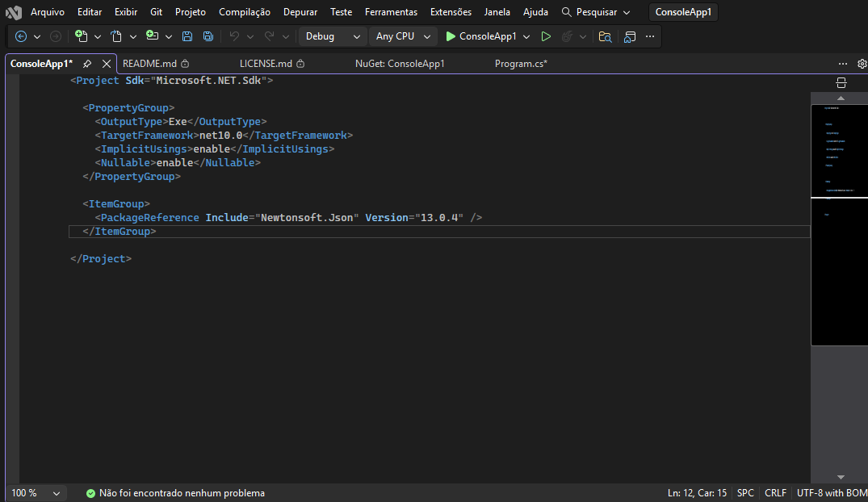
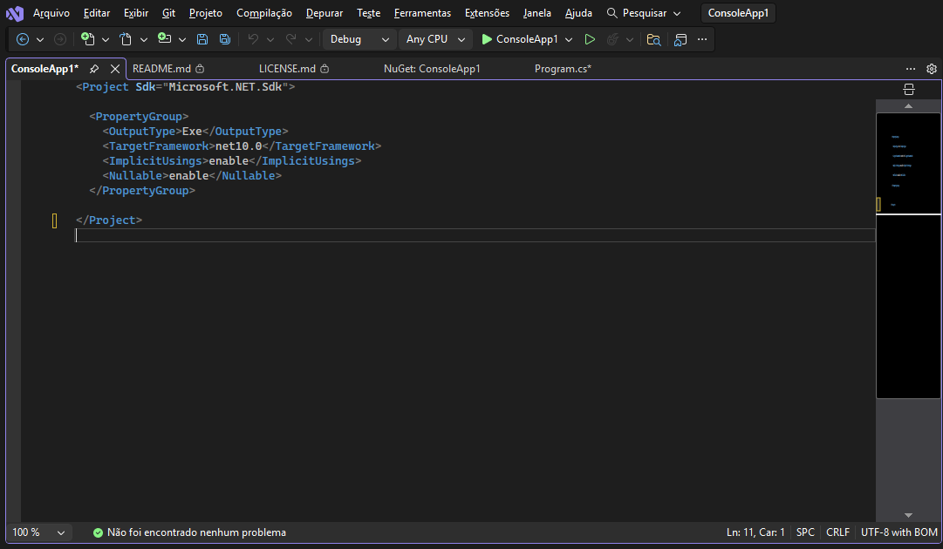
using Bogus;

var faker = new Bogus.Faker();
string nome = faker.Name.FullName();
string email = faker.Internet.Email();
string adress = faker.Address.FullAddress();
Console.WriteLine(nome);
Console.WriteLine(email);
Console.WriteLine(adress);

